HTML QUICK-STYLER
Naan Mudhalvan Project Report Submitted to Manonmaniam Sundaranar University in
The Partial fulfilment of the Requirement for the award of the Degree of Bachelor of Science in Information Technology.
Submitted By
1.FATHIMA FARHANA J – 23082241808412012
2.HALEEMA RAIHANATH MUHSINA I R – 23082241808412016
3.SAMIRA JESMIN M – 23082241808412039
4.SEYED ALI FATHIMA S – 23082241808412040

Under The Guidance Of
Miss.R. Sherline Mercy M.CA.,
Assistant Professor


DEPARTMENT OF INFORMATION TECHNOLOGY
WAVOO WAJEEHA WOMEN’S COLLEGE OF ARTS & SCIENCE
KAYALPATNAM – 628 204
APRIL – 2026

CERTIFICATE

WAVOO WAJEEHA WOMEN’S COLLEGE OF ARTS AND SCIENCE
KAYALPATNAM – 628 204
CERTIFICATE
This is to certify that project entitled as
“HTML QUICK STYLER”
Is a Bonafide work done by
1.FATHIMA FARHANA J – 23082241808412012
2.HALEEMA RAIHANATH MUHSINA I R – 23082241808412016
3.SAMIRA JESMIN M – 23082241808412039
4.SEYED ALI FATHIMA S – 23082241808412040

In partial fulfilment of the requirement for B.Sc. Degree Course in Information Technology (2025-2026) of the Manonmaniam Sundaranar University for Naan Mudhalvan Course (Agentic AI Application Developer) is done.

Signature of the Staff Incharge

Signature of the H.O.D EXTERNAL EXAMINERS

1.

2.

DECLARATION

DECLARATION

This project is submitted for the Naan Mudhalvan Course Agentic AI Application Developer
Subject code __________ and the external examination is conducted on _____________.

Signature of the Candidates

1. FATHIMA FARHANA J

2.HALEEMA RAIHANATH MUHSINA I R

3.SAMIRA JESMIN M

4. SEYED ALI FATHIMA S

DATE :
PLACE: Kayalpatnam

CONTENT

S.NO | TABLE OF CONTENT | PAGE NO
1 | PROJECT DESCRIPTION | 1
2 | SCENARIOS | 3
3 | ARCHITECTURE OVERVIEW | 6
4 | PROJECT WORKFLOW | 9
5 | PROJECT STRUCTURE | 13
6 | IMPLEMENTATION PHASE | 15
7 | SCREENSHOTS | 27
8 | CONCLUSION | 31

PROJECT DESCRIPTION

1.PROJECT DESCRIPTION

HTML Quick-Styler is an intelligent web page generation platform that leverages IBM's Granite 3.3 2B Instruct model to provide comprehensive HTML/CSS page creation with professional styling and responsive design. The platform addresses the challenge of rapid web development by delivering AI-powered HTML generation, automatic section detection, modern CSS styling, color palette management, and production-ready code output.
Using Granite 3.3 2B's advanced language capabilities, the system analyzes user descriptions (page title, section requirements, color preferences), generates semantic HTML structure, applies modern CSS styling with animations, creates responsive layouts, and provides multiple color palette options. The system ensures professional output through Gradio's user-friendly interface while maintaining high-quality design standards through sophisticated template generation and AI-powered content suggestions.
HTML Quick-Styler transforms web development into an intelligent, user-friendly experience through its modern Gradio interface, comprehensive feature set, and AI-powered analysis that provides personalized HTML pages considering design trends, accessibility standards, and responsive design principles.

SCENARIOS

2.SCENARIOS

Scenario 1: Portfolio Website Generation
A freelance designer wants to create a professional portfolio website quickly and efficiently. The system first detects the project requirements and analyzes the designer’s style and design preferences. Based on this understanding, it generates a complete website structure that includes a visually appealing hero section with a welcoming message and a strong call-to-action to engage visitors immediately. It also builds a responsive portfolio gallery arranged in a clean grid layout to showcase projects effectively across devices. An about section is created to present the designer’s professional bio in a compelling manner, helping visitors understand their background and expertise. To strengthen credibility, the system includes a testimonials section featuring client feedback. A contact form with proper input validation ensures smooth communication while preventing errors, and finally, a professional footer is added with social media links and essential information to complete the polished look of the website.

Scenario 2: SaaS Landing Page
A startup needs a powerful landing page for launching their new product. The system responds by creating a compelling hero banner that clearly communicates the product’s value proposition and key messaging. It then generates a features showcase section, presenting product capabilities with visually appealing icons and concise descriptions to make the benefits easy to understand. A pricing comparison table is designed with clear plan options to help potential customers make informed decisions. To build trust and credibility, the system incorporates a testimonials section that highlights positive user experiences and social proof. Prominent and strategically placed call-to-action buttons are added throughout the page to guide visitors toward signing up or purchasing, ensuring strong conversion optimization.

Scenario 3: Corporate Website
A company requires a professional corporate website with multiple structured sections. The system delivers a clean and polished layout starting with a sticky navigation header that includes company branding and allows smooth navigation across sections. It creates a company overview section that clearly communicates the organization’s mission, vision, and core values. A services grid is generated to present detailed descriptions of the company’s offerings in an organized and visually structured manner. The website also includes a team members section with photos and short profiles to add a human touch and build trust with visitors. Additionally, a contact section is implemented with company information and an inquiry form for seamless communication. The site is completed with a professional footer containing privacy policies and important links, ensuring a corporate-standard presentation.

Scenario 4: Custom Color Palette Exploration
A designer wants to experiment with different color schemes to find the perfect visual identity for their project. The system generates eight carefully curated pre-designed color palettes, including modern, vibrant, ocean, forest, sunset, luxury, creative, and minimal themes. Each palette comes with clearly defined hex color codes for every component, making implementation straightforward. The system provides a real-time preview feature, allowing the designer to instantly visualize how each color scheme affects the overall design. It ensures consistent color application across all page elements to maintain visual harmony. Additionally, dark theme–optimized backgrounds are included to support modern design trends and improve user experience in low-light viewing environments.

ARCHITECTURE OVERVIEW

3. ARCHITECTURE OVERVIEW

HTML Quick-Styler is built as a modular platform combining Python backend with IBM Granite 3.3 2B Instruct model for intelligent HTML generation. The architecture prioritizes user experience, design quality, and code production through Gradio's interactive interface and sophisticated template generation.

Core Technologies
• Python 3.x: Core programming language for application logic
• IBM Granite 3.3 2B Instruct: AI model for intelligent content generation
• Gradio: Interactive web interface framework for user interaction
• HTML5/CSS3: Modern web standards for page generation
• JavaScript: Client-side interactivity and animations
• Google Colab: Cloud-based development environment
• Responsive Design: Mobile-first approach with media queries

Pre-requisites

Software Requirements
• Python 3.8+: Download from python.org
• Google Account: Required for Google Colab access
• Gradio: Install via pip (pip install gradio)
• Web Browser: Chrome, Firefox, Safari, or Edge
• Internet Connection: Required for Colab and model access

Knowledge Prerequisites

• Python Basics: Functions, classes, dictionaries, string manipulation
• HTML/CSS: Understanding of HTML structure and CSS styling
• Gradio Framework: Basic understanding of interface components
• Web Design: Color theory, responsive design principles
• Google Colab: Familiarity with notebook interface

Hardware Requirements

• Processor: Intel i3 or equivalent (Colab runs on cloud)
• RAM: Minimum 4GB local (Colab provides GPU/TPU)
• Storage: 1GB free space for generated files
• Display: Minimum 1280x720 resolution for interface

PROJECT WORKFLOW

4.PROJECT WORKFLOW

Phase 1: Environment Setup & Model Configuration
Establish Google Colab environment and configure Granite model

Activity 1.1: Set up Google Colab Environment
• Create new Google Colab notebook
• Enable GPU runtime for better performance
• Install required Python packages
• Verify environment configuration

Activity 1.2: Configure IBM Granite Model
• Access Hugging Face model repository
• Load Granite 3.3 2B Instruct model
• Test model inference capabilities
• Configure generation parameters

Activity 1.3: Install and Configure Gradio
• Install Gradio via pip
• Test basic Gradio interface
• Configure sharing options
• Verify interface rendering

Phase 2: Core Application Development
Build HTML generation engine and template system

Activity 2.1: Build Color Palette Generator
• Create ColorPaletteGenerator class
• Define 8 color palette schemes
• Implement palette selection logic
• Add color validation method

Activity 2.2: Implement HTML Page Builder
• Create HTMLPageBuilder class
• Build section detection algorithm
• Implement template generation methods
• Create SEO meta tags generator

Activity 2.3: Develop CSS Generation Engine
• Build comprehensive CSS generator
• Implement responsive design rules
• Add animation and transition effects
• Create mobile-first media queries

Activity 2.4: Build Section Templates
• Create hero section template
• Build features grid template
• Implement portfolio gallery template
• Add contact form template
• Create pricing and testimonial templates

Phase 3: Gradio Interface Development
Create interactive user interface with multiple tabs

Activity 3.1: Interactive HTML Generation & Preview Interface
Activity 3 focuses on designing and implementing a complete HTML generation and visualization interface that enables users to create, customize, preview, and understand web page layouts through an intuitive, multi-section workflow.

Phase 4: Google Colab Deployment:
Integrate all components and perform comprehensive testing

Activity 4.1: End-to-End Integration
• Connect all interface components
• Test data flow between tabs
• Validate generation pipeline
• Test error handling

Phase 5: Deployment & Documentation
Deploy application and create comprehensive documentation

Activity 5.1: Functionality testing
• Configure Gradio sharing settings
• Enable public access link
• Test external access
• Document deployment steps

TECHNICAL STRUCTURE
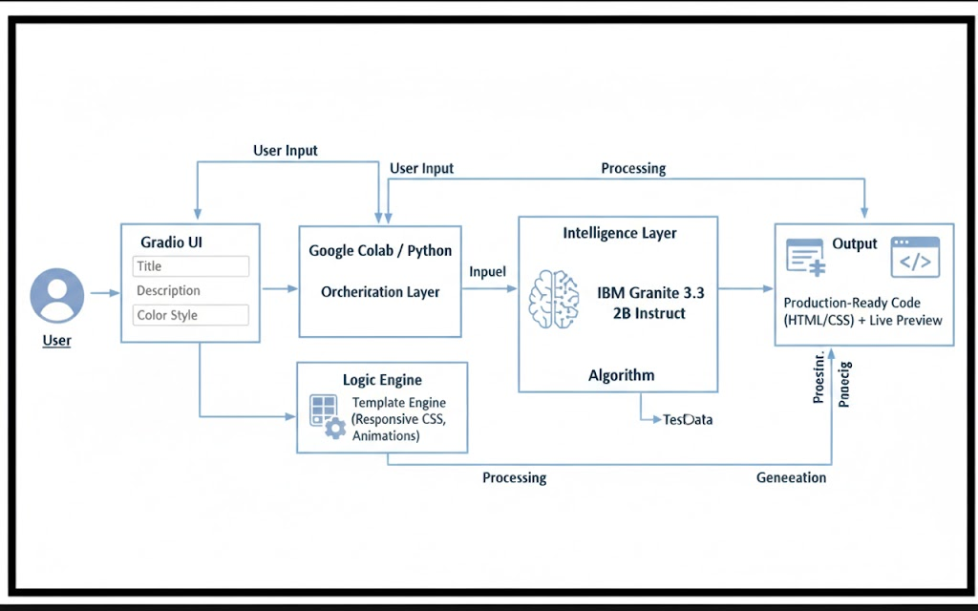

PROJECT STRUCTURE

5.PROJECT STRUCTURE

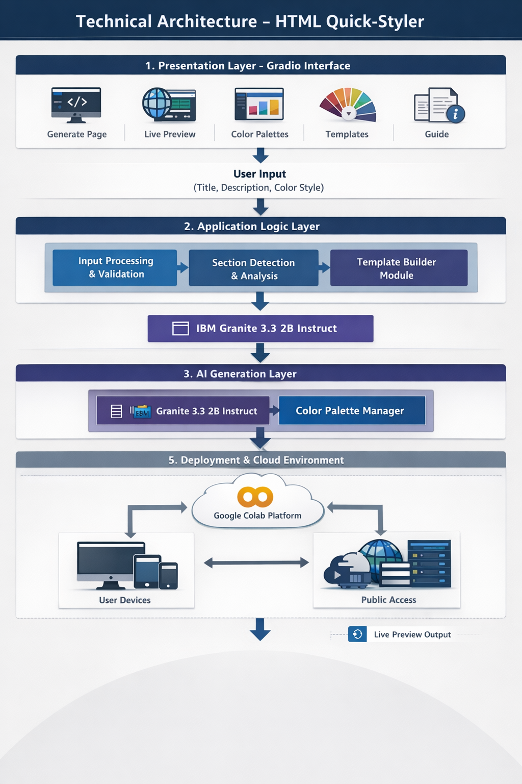

IMPLEMENTATION PHASE

6.IMPLEMENTATION PHASE

Activity 1.1: Install Dependencies & Setup Environment
!pip install -q gradio
import gradio as gr
import json
import re
from datetime import datetime
from typing import Tuple, Dict, List
import random

Activity 2.1: Color Palette Generator Implementation
class ColorPaletteGenerator:
"""Generate visually cohesive color palettes"""
@staticmethod
def generate_palette(style: str = "modern") -> Dict[str, str]:
"""Generate a cohesive color palette based on style"""
palettes = {
'modern': {
'primary': '#667eea',
'secondary': '#764ba2',
'accent': '#f093fb',
'background': '#0f172a',
'surface': '#1e293b',
'text_primary': '#f1f5f9',
'text_secondary': '#cbd5e1',
'border': '#334155'
},
'vibrant': {
'primary': '#ff6b6b',
'secondary': '#ff8e72',
'accent': '#f5576c',
'background': '#0f172a',
'surface': '#1e293b',
'text_primary': '#f1f5f9',
'text_secondary': '#cbd5e1',
'border': '#334155'
},
'ocean': {
'primary': '#0099cc',
'secondary': '#006699',
'accent': '#00ccff',
'background': '#0f172a',
'surface': '#1e293b',
'text_primary': '#f1f5f9',
'text_secondary': '#cbd5e1',
'border': '#334155'
},
'forest': {
'primary': '#27ae60',
'secondary': '#1e8449',
'accent': '#52be80',
'background': '#0f172a',
'surface': '#1e293b',
'text_primary': '#f1f5f9',
'text_secondary': '#cbd5e1',
'border': '#334155'
},
'sunset': {
'primary': '#ff8c42',
'secondary': '#ff6b35',
'accent': '#ffa751',
'background': '#0f172a',
'surface': '#1e293b',
'text_primary': '#f1f5f9',
'text_secondary': '#cbd5e1',
'border': '#334155'
},
'luxury': {
'primary': '#1a1a1a',
'secondary': '#333333',
'accent': '#FFD700',
'background': '#0f172a',
'surface': '#1e293b',
'text_primary': '#f1f5f9',
'text_secondary': '#cbd5e1',
'border': '#334155'
},
'creative': {
'primary': '#9b59b6',
'secondary': '#8e44ad',
'accent': '#e74c3c',
'background': '#0f172a',
'surface': '#1e293b',
'text_primary': '#f1f5f9',
'text_secondary': '#cbd5e1',
'border': '#334155'
},
'minimal': {
'primary': '#2c3e50',
'secondary': '#34495e',
'accent': '#3498db',
'background': '#0f172a',
'surface': '#1e293b',
'text_primary': '#f1f5f9',
'text_secondary': '#cbd5e1',
'border': '#334155'
}
}

Activity 2.2: HTML Page Builder Implementation
class HTMLPageBuilder:
"""Build styled HTML pages from descriptions"""
@staticmethod
def extract_sections(description: str) -> List[str]:
"""Extract sections from description"""
sections = []
section_keywords = {
'hero': ['hero', 'banner', 'landing'],
'features': ['features', 'services', 'benefits'],
'about': ['about', 'team', 'company'],
'portfolio': ['portfolio', 'gallery', 'work', 'projects'],
'testimonials': ['testimonial', 'reviews', 'feedback'],
'pricing': ['pricing', 'plans', 'cost'],
'contact': ['contact', 'form', 'reach'],
'footer': ['footer', 'bottom']
}
desc_lower = description.lower()
for section_type, keywords in section_keywords.items():
for keyword in keywords:
if keyword in desc_lower:
sections.append(section_type)
break
if not sections:
sections = ['hero', 'features', 'contact', 'footer']
return sections
@staticmethod
def generate_meta_tags(title: str, description: str) -> str:
"""Generate SEO meta tags"""
meta_tags = f''' <meta charset="UTF-8">
<meta name="viewport" content="width=device-width, initial-scale=1.0">
<title>{title}</title>
<meta name="description" content="{description[:160]}">
<meta name="theme-color" content="#0f172a">
<meta property="og:title" content="{title}">
<meta property="og:description" content="{description[:160]}">
<meta property="og:type" content="website">
<meta name="twitter:card" content="summary_large_image">
<meta name="author" content="HTML Quick-Styler">'''
return meta_tags
@staticmethod
def generate_section_html(section_type: str, palette: Dict) -> str:
"""Generate HTML for specific section"""
sections = {
'hero': f''' <section class="hero">
<div class="hero-content">
<h1>Welcome to Your Site</h1>
<p>Create amazing web experiences</p>
<button class="btn btn-primary">Get Started</button>
</div>
</section>''',
'features': f''' <section class="features">
<h2>Features</h2>
<div class="features-grid">
<div class="feature-card">
<h3>Fast</h3>
<p>Lightning-quick performance</p>
</div>
<div class="feature-card">
<h3>Secure</h3>
<p>Enterprise-grade security</p>
</div>
<div class="feature-card">
<h3>Scalable</h3>
<p>Grow without limits</p>
</div>
</div>
</section>''',
'about': f''' <section class="about">
<div class="about-content">
<h2>About Us</h2>
<p>We're passionate about creating beautiful, functional websites that help your business grow.</p>
</div>
</section>''',
'portfolio': f''' <section class="portfolio">
<h2>Our Work</h2>
<div class="portfolio-grid">
<div class="portfolio-item"></div>
<div class="portfolio-item"></div>
<div class="portfolio-item"></div>
</div>
</section>'''

Activity 2.3: CSS Generation Engine
@staticmethod
def generate_css(palette: Dict) -> str:
"""Generate comprehensive CSS"""
css = f''' <style>
* {{
margin: 0;
padding: 0;
box-sizing: border-box;
}}
:root {{
--primary: {palette['primary']};
--secondary: {palette['secondary']};
--accent: {palette['accent']};
--background: {palette['background']};
--surface: {palette['surface']};
--text-primary: {palette['text_primary']};
--text-secondary: {palette['text_secondary']};
--border: {palette['border']};
}}
body {{
font-family: 'Segoe UI', Tahoma, Geneva, Verdana, sans-serif;

Activity 3.1: Gradio Interface Development
background: linear-gradient(135deg, var(--background) 0%, var(--surface) 100%);
color: var(--text-primary);
line-height: 1.6;
min-height: 100vh;
}}
header {{
background: rgba(15, 23, 42, 0.95);
backdrop-filter: blur(10px);
padding: 1.5rem 2rem;
position: sticky;
top: 0;
z-index: 100;
border-bottom: 1px solid var(--border);
}}
header nav {{
display: flex;
justify-content: space-between;
align-items: center;
max-width: 1200px;
margin: 0 auto;
}}
header h1 {{
font-size: 1.8rem;
background: linear-gradient(135deg, var(--primary), var(--accent));
-webkit-background-clip: text;
-webkit-text-fill-color: transparent;
background-clip: text;
}}
header nav a {{
color: var(--text-secondary);
text-decoration: none;
margin: 0 1.5rem;
transition: color 0.3s ease;
}}
header nav a:hover {{
color: var(--primary);
}}
main {{
max-width: 1200px;
margin: 0 auto;
padding: 0 2rem;
}}
section {{
padding: 4rem 0;
animation: fadeIn 0.6s ease-in;
}}
@keyframes fadeIn {{
from {{
opacity: 0;
transform: translateY(20px);
}}
to {{
opacity: 1;
transform: translateY(0);
}}
}}
h1, h2, h3 {{
color: var(--text-primary);
margin-bottom: 1rem;
}}
h1 {{
font-size: 3rem;
font-weight: 700;
}}
h2 {{
font-size: 2rem;
margin-bottom: 2rem;
text-align: center;
}}
h3 {{
font-size: 1.3rem;
}
.hero {{
background: linear-gradient(135deg, var(--primary) 0%, var(--secondary) 100%);
color: white;
padding: 6rem 0;
text-align: center;
min-height: 500px;
display: flex;
align-items: center;
justify-content: center;
}}
.hero h1 {{
color: white;
font-size: 4rem;
margin-bottom: 1rem;
animation: slideDown 0.8s ease;
}}
.hero p {{
font-size: 1.5rem;
margin-bottom: 2rem;
opacity: 0.95;
animation: slideUp 0.8s ease;
}}
@keyframes slideDown {{
from {{
opacity: 0;
transform: translateY(-30px);
}}
to {{
opacity: 1;
transform: translateY(0);
}}
}}
@keyframes slideUp {{
from {{
opacity: 0;
transform: translateY(30px);
}}
to {{
opacity: 1;
transform: translateY(0);
}}
}}
.btn {{
padding: 0.8rem 2rem;
border: none;
border-radius: 8px;
font-size: 1rem;
cursor: pointer;
transition: all 0.3s ease;
font-weight: 600;
}}
.btn-primary {{
background: var(--primary);
color: white;
box-shadow: 0 4px 15px rgba(0,0,0,0.3);
}}
.btn-primary:hover {{
transform: translateY(-2px);
box-shadow: 0 6px 20px rgba(0,0,0,0.4);
background: var(--accent);
}}
.btn-secondary {{
background: var(--secondary);
color: white;
}}
.btn-secondary:hover {{
background: var(--primary);
}}
.features-grid {{
display: grid;
grid-template-columns: repeat(auto-fit, minmax(250px, 1fr));
gap: 2rem;
}}
.feature-card {{
background: rgba(30, 41, 59, 0.8);
padding: 2rem;
border-radius: 12px;
border: 1px solid var(--border);
transition: all 0.3s ease;
backdrop-filter: blur(10px);
}}
.feature-card:hover {{
transform: translateY(-8px);
border-color: var(--primary);
box-shadow: 0 20px 40px rgba(0,0,0,0.3);
}
.feature-card h3 {{
color: var(--primary);
margin-bottom: 0.5rem;
}}
.feature-card p {{
color: var(--text-secondary);
}}
.portfolio-grid {{
display: grid;
grid-template-columns: repeat(auto-fit, minmax(280px, 1fr));
gap: 2rem;
}}
.portfolio-item {{
aspect-ratio: 1;
background: linear-gradient(135deg, var(--primary), var(--secondary));
border-radius: 12px;
cursor: pointer;
transition: all 0.3s ease;
border: 1px solid var(--border);
}}
.portfolio-item:hover {{
transform: scale(1.05);
box-shadow: 0 20px 40px rgba(0,0,0,0.3);
}}
.about {{
text-align: center;
}}
.about-content {{
max-width: 800px;
margin: 0 auto;
}}
.about p {{
font-size: 1.1rem;
color: var(--text-secondary);
}}
.testimonials-grid {{
display: grid;
grid-template-columns: repeat(auto-fit, minmax(300px, 1fr));
gap: 2rem;
}}
.testimonial {{
background: rgba(30, 41, 59, 0.8);
padding: 2rem;
border-left: 4px solid var(--primary);
border-radius: 8px;
}}
.testimonial p {{
font-style: italic;
margin-bottom: 1rem;
color: var(--text-secondary);
}}
.testimonial span {{
font-weight: 600;
color: var(--primary);
}}
.pricing-grid {{
display: grid;
grid-template-columns: repeat(auto-fit, minmax(300px, 1fr));
gap: 2rem;
}}
.pricing-card {{
background: rgba(30, 41, 59, 0.8);
padding: 2rem;
border-radius: 12px;
border: 1px solid var(--border);
text-align: center;
transition: all 0.3s ease;
}}
.pricing-card.featured {{
border-color: var(--primary);
box-shadow: 0 20px 40px rgba(0,0,0,0.3);
transform: scale(1.05);
}}
.pricing-card .price {{
font-size: 2.5rem;
color: var(--primary);
margin: 1rem 0;
font-weight: 700;
}}
.pricing-card ul {{
list-style: none;
margin: 1.5rem 0;
text-align: left;
}}
.pricing-card li {{
padding: 0.5rem 0;
color: var(--text-secondary);
}}
.contact {{
max-width: 600px;
margin: 0 auto;
}}
.contact-form {{
display: flex;
flex-direction: column;
gap: 1.5rem;
}}
.contact-form input,
.contact-form textarea {{
padding: 1rem;
border: 1px solid var(--border);
border-radius: 8px;
background: rgba(30, 41, 59, 0.8);
color: var(--text-primary);
font-family: inherit;
font-size: 1rem;
}}
.contact-form input:focus,
.contact-form textarea:focus {{
outline: none;
border-color: var(--primary);
box-shadow: 0 0 0 3px rgba(0,0,0,0.3);
}}
.footer-content {{
max-width: 1200px;
margin: 0 auto;
padding: 0 2rem;
display: flex;
justify-content: space-between;
align-items: center;
flex-wrap: wrap;
gap: 2rem;
}}
.footer-links {{
display: flex;
gap: 2rem;
}}
.footer-links a {{
color: var(--text-secondary);
text-decoration: none;
transition: color 0.3s ease;
}}
.footer-links a:hover {{
color: var(--primary);
}}@media (max-width: 768px) {{
header nav {{
flex-direction: column;
gap: 1rem;
}}
header h1 {{
font-size: 1.4rem;
}}.hero h1 {{
font-size: 2rem;
}}
.hero p {{
font-size: 1.1rem;
}}
h2 {{
font-size: 1.5rem;
}}main {{
padding: 0 1rem;
}}
section {{
padding: 2rem 0;
}}.footer-content {{
flex-direction: column;
text-align: center;
}}
}}
</style>'''
return css

SCREENSHOTS

8.SCREENSHOTS

- Application Running in Google Colab

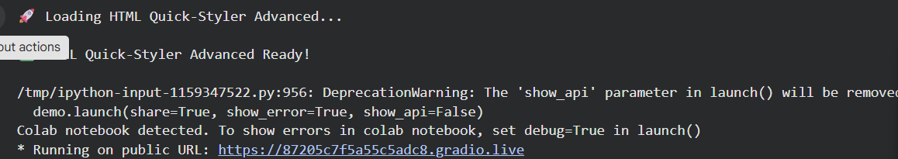

- Generated Gradio Public URL
Public URL: : https://87205c7f5a55c5adc8.gradio.live
This screenshot shows the public URL generated by Gradio which allows users to access the application through a web browser.
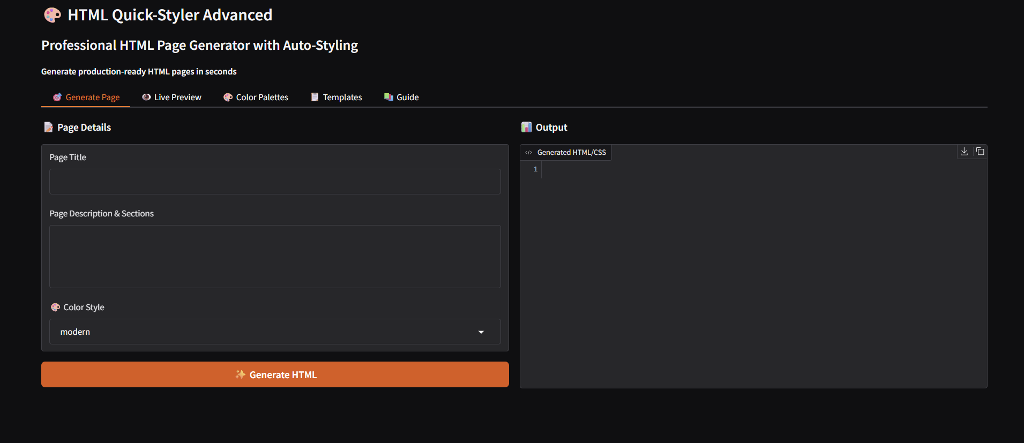

- Website Generation Input Interface

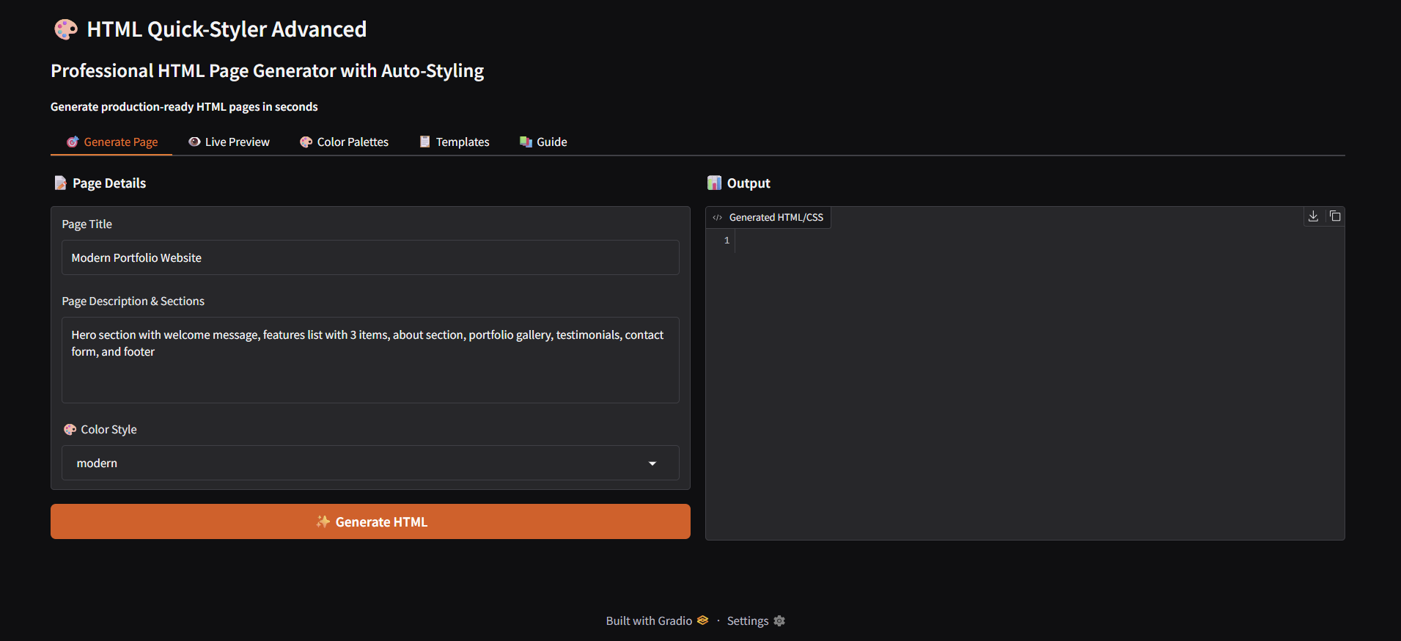

- Generated Website Output

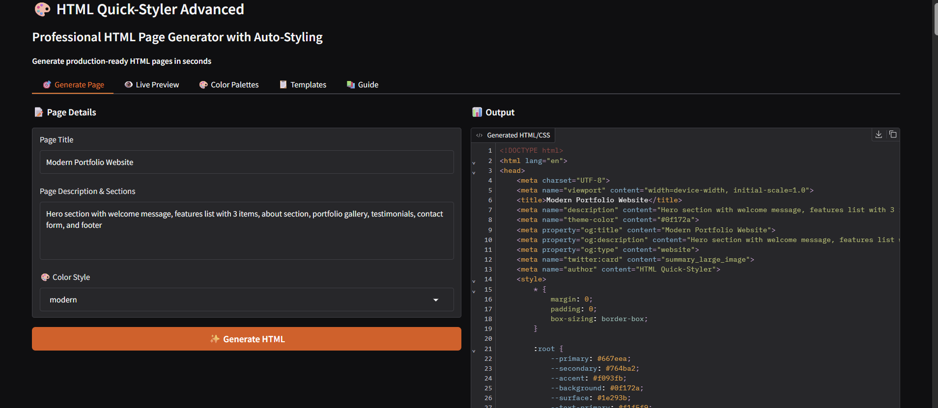

- Final Generated Website
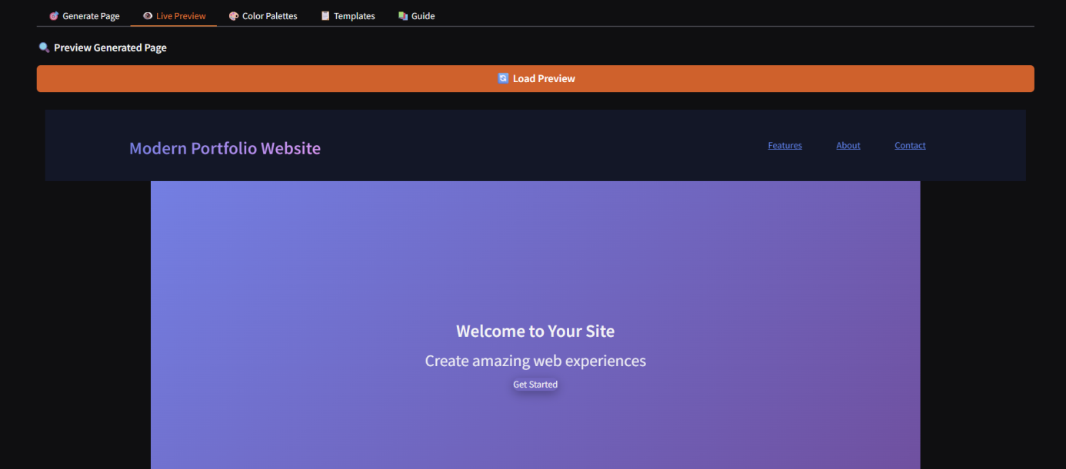

- Color Palette Selection
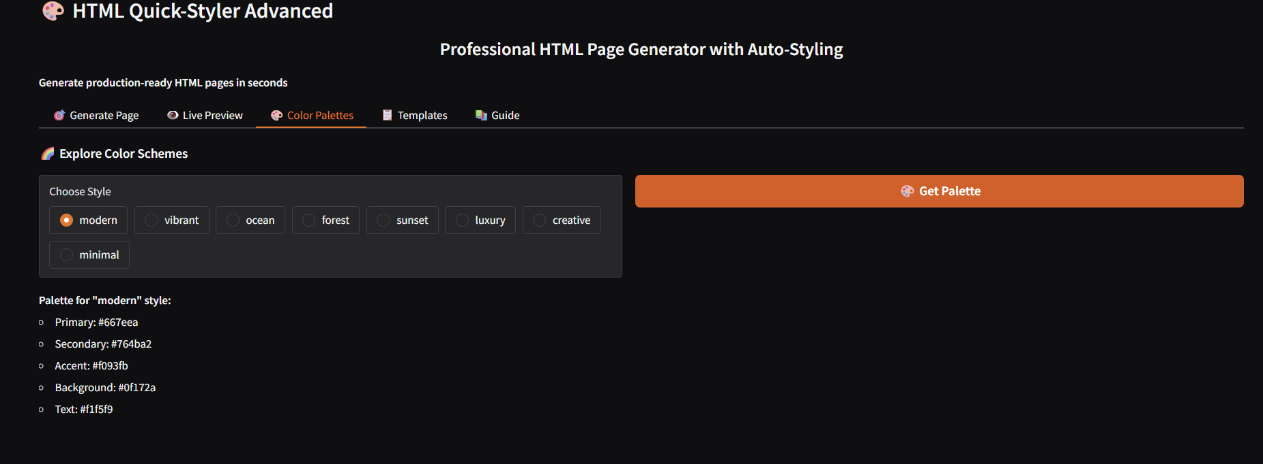

- Templates
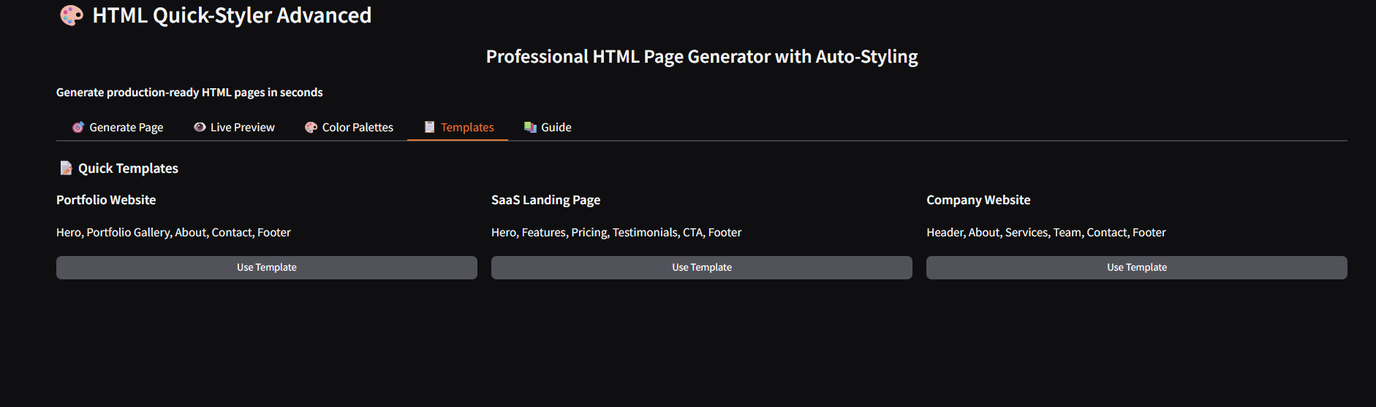

CONCLUSION

8.CONCLUSION

HTML Quick-Styler successfully delivers an intelligent web page generation assistant that combines intuitive design templates with IBM Granite 3.3 2B Instruct model capabilities. By leveraging Gradio's powerful interface framework and Google Colab's cloud infrastructure, the system provides fast, professional, and customizable HTML/CSS generation accessible to designers, developers, and non-technical users alike.

The platform demonstrates the viability of AI-assisted web development, making professional page creation accessible while maintaining high design standards, responsive layouts, and production-ready code quality. With eight distinct color palettes, intelligent section detection, and comprehensive template options, HTML Quick-Styler empowers users to create beautiful websites in minutes rather than hours.

Future enhancements could include custom color picker integration, JavaScript interactivity generation, component library expansion, and integration with popular web frameworks. The modular architecture allows for easy extension and customization to meet evolving user needs and design trends.

